LEXINGTON Round Curved Neon Bed

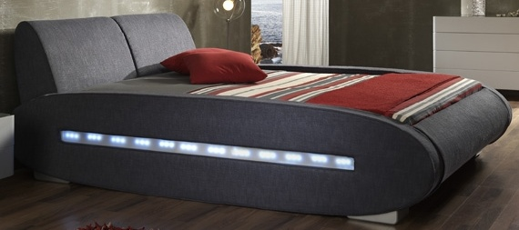

|  |
| --- |
| **DESCRIPTION** |
| LEXINGTON introduces stylish bed with a rumple form skin on the middle and a hard wooden coated skin on the sides. This set of bed is sure to create the perfect look in any home. The rich wood of the bed pairs perfectly with many different styles and rooms. Perfect for heart of the house, your guests will love this comfortable mood lifting bed. Automatic neon bulbs are used on the side this increases the look and changes the style from a natural look to modified version. |

|  |  |  |
| --- | --- | --- |
| **Price** | **4500$** | |
| **Dimensions** | **H** x **W** x **L** | **20in x 54in x 75in** |
| **Features** | **The Fiber used on the skin of the bed is made from cross polymer linkage which protects it from water getting in and dust particles are also trapped by the bed.** | |
| **Finished** | **Duff Grey Leather Form** | |
| **Available in** | **Grey Only** | |